Subject: Cloud Helpdesk System User Guide | Effectivity Date:
Issued by: MIS Department | Revised Date:
Approved by: | Last Board Review Date
OVERVIEW
Cloud Helpdesk is a free online IT Tool developed by spiceworks to help IT Administrators, IT Technicians, and System Developers to monitor, track, and attend to pending tasks at hand via online job ticketing application. This is a cloud-based application that doesn’t require server procurement, setup and maintenance will not be an issue. The IT Team can also do the tracking of tickets via Mobile application.
OBJECTIVE
- This will allow the MIS Department to be more organized, focused, efficient and effective on handling IT related concerns.
- To provide a detailed user guide manual to SAMULCO employees on how to properly use the cloud Helpdesk Portal.

USER GUIDE
- Step #1 – users should go to https://mis-samulco.on.spiceworks.com/portal_registrations

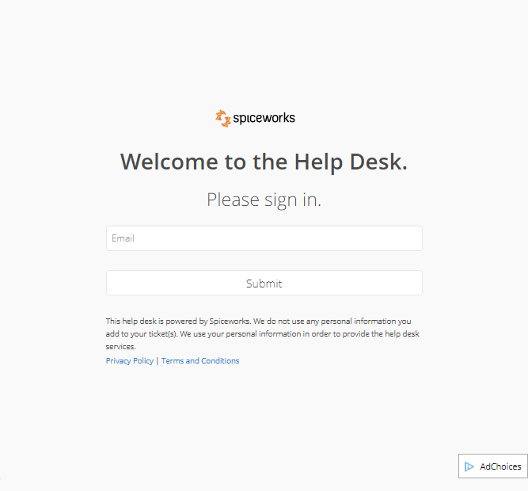
USERS REGISTRATION PORTAL

- End-Users should put in a valid cooperative email address.
- After putting in a valid email Address click on SUBMIT button to proceed.
- Moments after clicking the SUBMIT button, a notification email that contains a highlighted link will be sent to your registered email. This link will redirect you to the CLOUD HELPDESK TICKET PORTAL

Sample email that user will receive that contains a link that will redirect user to CLOUD HELPDESK PORTAL

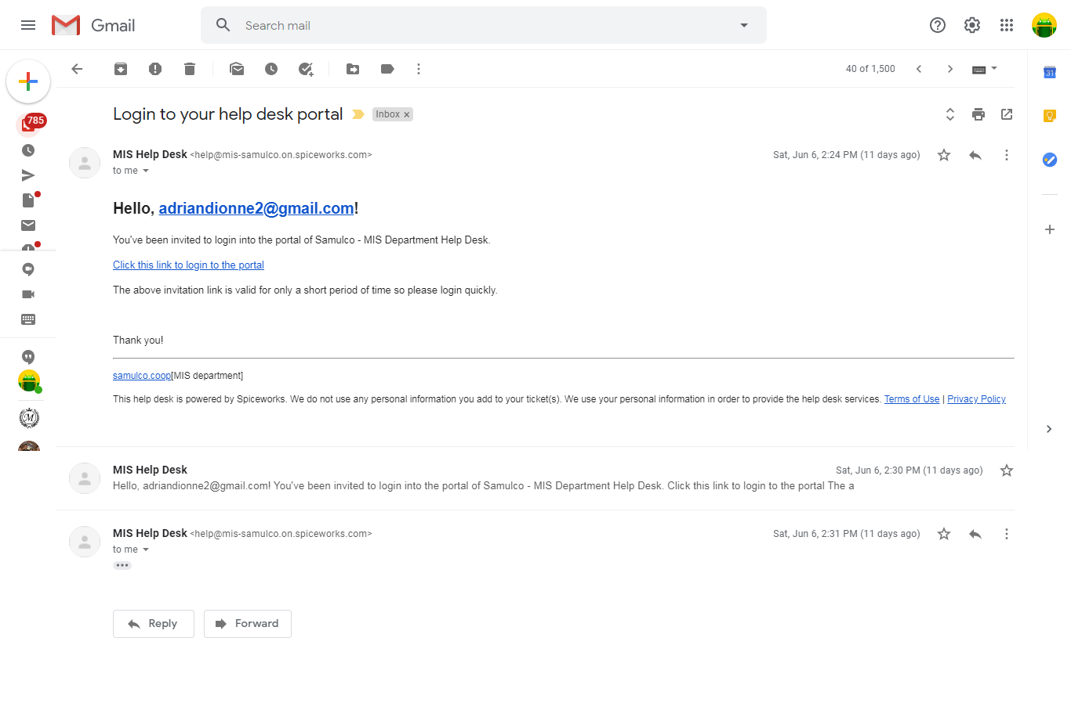

CONTENT OF EMAIL USER WILL RECEIVE AFTER REGISTRATION

- Step #2 – Users should fill in the information needed on CLOUD HELPDESK TICKET PORTAL
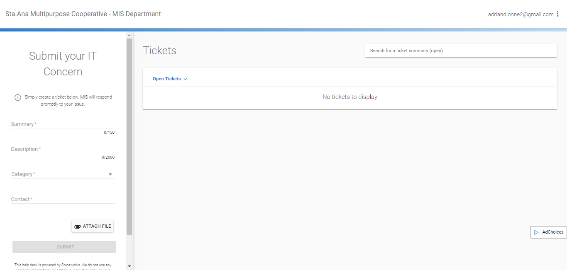
CLOUD HELPDESK TICKET PORTAL
- Summary. Ticket Title
- Description. Brief Description of the Problem
- Category. End users will select which category his/her problem will fall into.
- Contact. Requestor should provide a contact number. MIS support could speak to the requestor for any clarification.
- Attach File. Requesters can do file attachment to support their concerns.
After filling in all information needed, users can now submit his/her request to the MIS department. MIS will now then receive the users request and will immediately attend on user’s request.
On the right side of the TICKET PORTAL PANEL, users can see the Open tickets status and thread. To view ticket updates, users should not attempt to close the cloud helpdesk ticket portal tab on the user's web browser.
To view ticket updates, on the right side of the ticket portal panel user should select the ticket he/she would like to view for updates. A thread will be created automatically once a user will submit a ticket for help support.
When a user notices that the ticket he/she created is not anymore on the open ticket thread, He/she can check on the closed ticket tab by filtering the tickets using a list down selection button as his/her ticket might be already closed or already been resolved.
NOTE: Requestor can update a thread; make follow up, and re-open closed tickets. Whenever users accidentally closes the Cloud Helpdesk Portal Browser tab. He/she could still check on updates by checking on his/her registered email.

ACKNOWLEDGEMENT

I have read, understood and agree to abide by all the policies and procedures in this document and I understand my responsibility as an employee.

Printed Name and Signature

Designation

Date Signed

